|  |  |
| --- | --- |
| How to Submit Final Report |  |

If your project does not have an Ideas page, see [How to Create Ideas Project Site](https://aerospacecloud.sharepoint.com/sites/iLAB/Shared%20Documents/02%20-%20iLab%20Ventures/10%20-%20FY20/Ideas%20Documentation/Ventures%20How%20to%20Create%20Ideas%20Project%20Site.pdf) first.

**Final Report & Template**

The template for the final report [can be found on Sharepoint](https://aerospacecloud.sharepoint.com/sites/iLAB/Shared%20Documents/02%20-%20iLab%20Ventures/10%20-%20FY20/FY20_Ventures_final_LastName_ShortTitle.pptx?web=0). This link will automatically download the template to your computer. Modify the template and rename it in this format to add your name and short title (the words in green below):

FY20_Ventures_final_**LastName_ShortTitle**.pptx

**How to Submit Ventures Final Report** [on the Ideas portal](http://ideas.aero.org/)

Go to ideas.aero.org

Use the Search bar to search for your project



Click the Edit button on the upper left

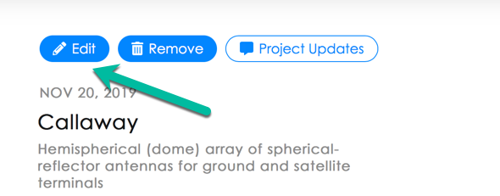

Upload the report to the Drag & drop or Browse additional documents box

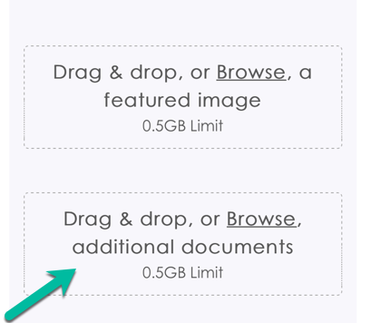

Scroll down and click Submit

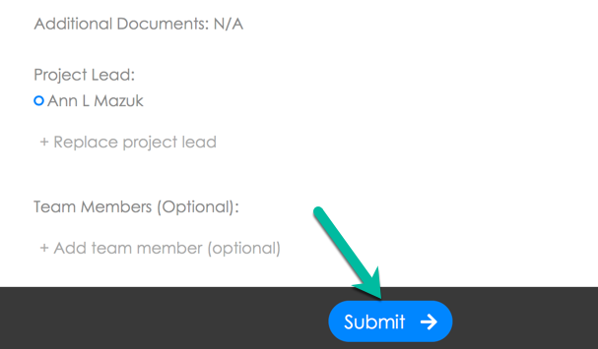

Congratulations, your final report has been uploaded to the Ideas page!